

Apollo 3D

Carbon Reduction Plan

Publication date: 01/11/2024

Contents

Commitment to achieving Net Zero 3
Baseline Emissions Footprint 3
Data 5
Assessment 5
Data improvement plan 5
Emissions reduction targets 6
Completed carbon reduction projects 7
Future carbon reduction initiatives 7
Declaration and Sign Off 7
Appendix – Calculations 8
Scope 1: 8
Scope 2: 8
Scope 3 8

Commitment to achieving Net Zero
Apollo 3D is committed to achieving Net Zero emissions by 2045 at the latest.

Baseline Emissions Footprint
Baseline emissions are a record of the greenhouse gases that have been produced in the past and were produced prior to the introduction of any formal strategies to reduce emissions. Baseline emissions are the reference point against which emissions reduction can be measured.

 | Baseline Emissions  For year: 01/11/2023 – 31/10/2024 | tCO₂e
 | Scope 1 – Direct emissions | 0.00
 | Scope 2 - Electricity | 4.86
 | Scope 3
 | Electricity transmission and distribution (inc WTT) | 1.60
 | Waste generated in operations | 0.37
 | Business travel | 6.73
 | Employee commuting | 3.16
 | Employee home working | 0.94
 | Total Emissions | 17.67
 | Per Employee Emissions | 1.96
Additional Details relating to the Baseline Emissions calculations
The figures in this report refer to emissions under Apollo 3D operational control. The conversion factors used are for location-based reporting. Part of this plan is to improve the scope and accuracy of data going forward. All data has been compiled with reference to and using data from:
- https://ghgprotocol.org/corporate-standard
- https://www.gov.uk/government/collections/government-conversion-factors-for-company-reporting (2023 and 2024 data set)
The figures and information used in calculations have been provided as accurate to the best of our knowledge and as far as practicable we have assumed that figures are representative of our operations. We undertake a continual process of improving our data quality. In the case that we identify any material changes, we may recalculate the data in the future.

Current Emissions Reporting

As baseline

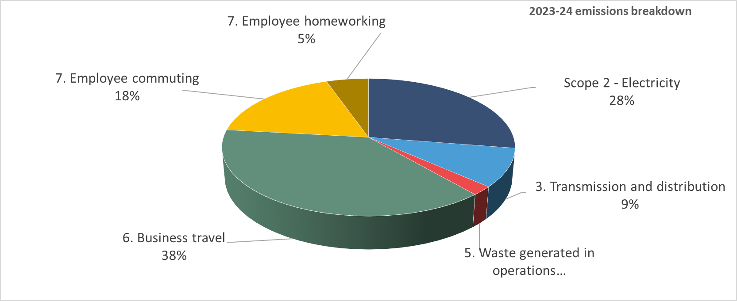

Data

Assessment
Scope / category | Relevance  (materiality based) | Data quality  (1 = certain,  5 = uncertain)
Scope 1 – Natural gas | Not applicable
Scope 1 – Company fuel | Not applicable
Scope 1 – Fugitive emissions | Not applicable
Scope 2 - Electricity | High – estimated | 5
Scope 3
1. Purchased goods and services | No data available this year | -
2. Capital goods | No data available this year | -
3. Transmission and distribution (gas and electricity) | High – estimated | 5
4. Upstream transportation and distribution | No data available this year | -
5. Waste generated in operations | Low – estimated | 5
6. Business travel | High – extrapolated from typical week | 4
7. Employee commuting and homeworking | High – extrapolated from typical week | 4
8. Upstream leased assets | Not applicable | -
9. Downstream transportation and distribution | Not applicable | -
10. Processing of sold products | Not applicable | -
11. Use of sold products | No data available this year | -
12. End-of-life treatment of sold products | Not applicable | -
13. Downstream leased assets | Not applicable | -
14. Franchises | Not applicable | -
15. Investment | Not applicable | -
* will be reported when data is available

Data improvement plan
Our ambition is to:

Category | Action
Scope 2 | Capture kwh from meter readings or invoices monthly
3.1, 3.2, 3.4, 3.5 | Engage suppliers to encourage and support them to provide emissions data and their own Net Zero plans.
3.6 | Capture business travel distance and mode of travel at time of travel or expense claim
3.7 | Capture commuting data through time and attendance systems
Various | Longer term we will work with customers to understand the emissions associated with use of products and services

Emissions reduction targets
In order to progress to achieving Net Zero, we have adopted the carbon reduction targets detailed in the graph below.
These targets will be updated and recalculated as additional Scope 3 categories are added and data quality is improved (if changes create >5% variance in original calculations).
We project that carbon emissions will decrease to circa 12.7 tonnes by 2030. This is a reduction of 29% from our baseline year, on average a 4.9% year on year reduction.
Our reduction path is plotted below.
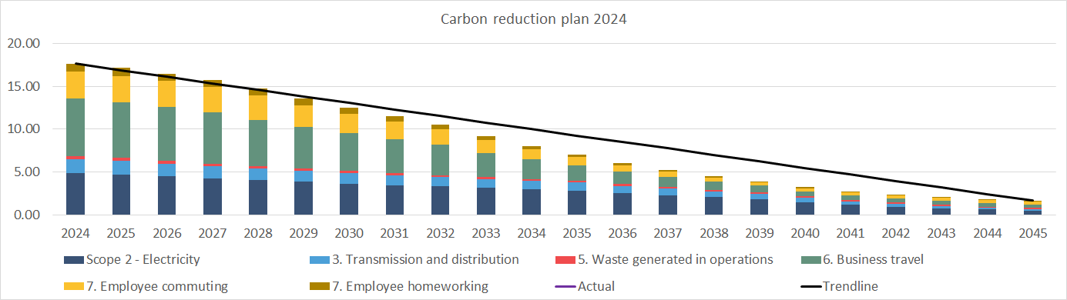
As our footprint is dominated by electricity use and employee travel, we have assumed reductions from government projected grid electricity decarbonisation and the adoption of lower carbon vehicles and fuels from 2030 based on current legislation and manufacturer plans.
The plan assumes some unavoidable emissions will remain by 2045, and these will be offset via a verified method of atmospheric CO₂ removal.
We anticipate this path will change significantly over time as our options are evaluated and technology changes.

Completed carbon reduction projects
Adoption of air sourced heat pumps for space heating.

Future carbon reduction initiatives
- Consider potential to invest / collaborate to make solar panel generated electricity available on site.
- Encourage and incentivise employees to transition to lower carbon vehicles upon replacement; including installation of EV charging points and consideration of EV salary sacrifice schemes.
- Adopt a green travel plan.
- Engage supply chain to understand and where possible support their carbon reduction plan development and delivery.
- Engage customers to understand and where possible support their carbon reduction plan development and delivery.

Declaration and Sign Off
This Carbon Reduction Plan has been completed in accordance with PPN 06/21 and associated guidance and reporting standard for Carbon Reduction Plans.
Emissions have been reported and recorded in accordance with the published reporting standard for Carbon Reduction Plans and the GHG Reporting Protocol corporate standard, the Corporate Value Chain (Scope 3) Standard.and uses the appropriate Government emission conversion factors for greenhouse gas company reporting.
The Scope 3 emissions reported have been calculated in accordance with the published reporting standard for Carbon Reduction Plans and the Corporate Value Chain (Scope 3) Standard.
This Carbon Reduction Plan has been reviewed and signed off by the board of directors.

Signed on behalf of Apollo 3D:

………………………………………………………………….Date: ……………………….……….

Appendix – Calculations
All conversion factors applied to relevant units to generate Kg CO₂e, then reported as t CO₂e.

Scope 2:
Typical UK office energy use per square meter was assumed, with a heating efficiency gain applied to account for heat pump usage the primary heat source. Standard electricity conversion factors were applied as part of the generation of the bespoke emissions factor*.

Scope 3

3.3 Transmission and distribution
Electricity – Applying the scope 2 electricity data to the appropriate conversion factors*

Note: In this category we have included well-to-tank emissions

3.5 Waste generated in operations
Waste figures estimated from typical office use per person applied to the person days reported for office use, with split between incineration, recycling and landfill from national averages, using the appropriate conversion factors. *

3.6 Business travel
Business travel mileage was calculated from typical week scenarios assuming an average distance travelled in a client facing day to be 40 miles. The relevant conversion factors* for average vehicles were applied.

3.7 Employee commuting and home working

Typical weekly commuting distances per week were multiplied by working weeks in the year and the average car emissions factors* applied.

Full time equivalent working hours from home had the relevant conversion factor* applied.

* Taken from https://www.gov.uk/government/collections/government-conversion-factors-for-company-reporting for relevant years

https://ghgprotocol.org/corporate-standard
https://ghgprotocol.org/standards/scope-3-standard
https://www.gov.uk/government/collections/government-conversion-factors-for-company-reporting

